**experChess Games Datahub**

**Final Project Part 3**

**Web App Design**

By

Hunter Sikora

Gunturu Sharath Babu

Saddam Al-Zubaidi

**Part 1. Web App Architecture**

**Overview:** Our web application follows an MVC schema.

* **Model:** We are using MySQL hosted by pythonanywhere.com to hold our Chess game data
* **View:** We are using Bootstrap to create the front-end layout for our web application
* **Controller:** We will be using Flask, a Python web framework for the controller of the website.

**1. Data Storage**

For local development, such as creating queries, we use MySQL Workbench with local servers. For the website itself, pythonanywhere will host a MySQL database. See below for the architecture.

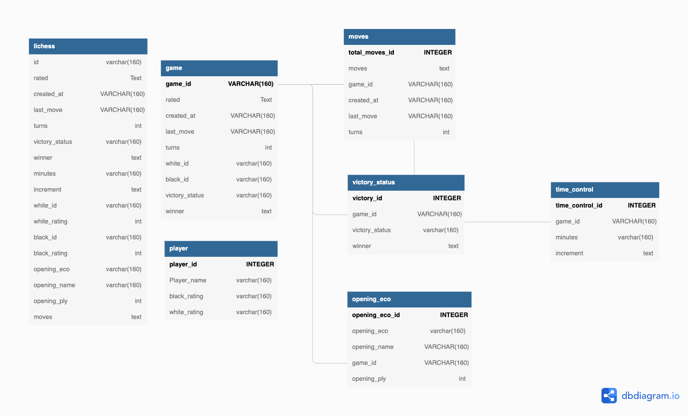

**2. Languages - Back End**

We use Flask, a Python web framework for backend development.

**3. Database Access/Connections/Security**

The database can only be accessed by users with the username and password to the database through PythonAnywhere.com. PythonAnywhere blocks outside access to their MySQL database via firewalls.

**4. Languages - Front End**

We are using Bootstrap as a scaffold for the application's front end. This will include HTML, CSS, and JavaScript. Python will be embedded into the HTML code as well.

**5. App Deployment**

We will be deploying our website on PythonAnywhere.

**6. App Interactivity**

Our application includes a database of Chess games for Amateur players to explore patterns and statistics of their peers' games. Through this database, we will provide the best performing opening and a wealth of other statistics at different levels of chess to give beginners a better idea of the patterns they will see at lower

levels of Chess.

**7. Architecture**

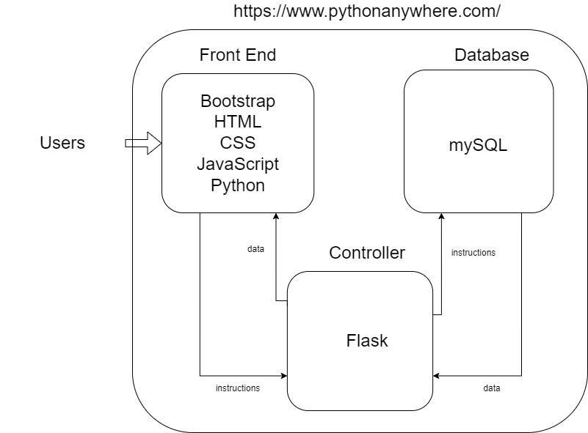

**Part 2. Web App Layout**

We have used Figma to design our web app layouts. There will be a total of three pages:

* Intro page
* Main page
* Graph page

The intro page will allow the user to enter their name or nickname: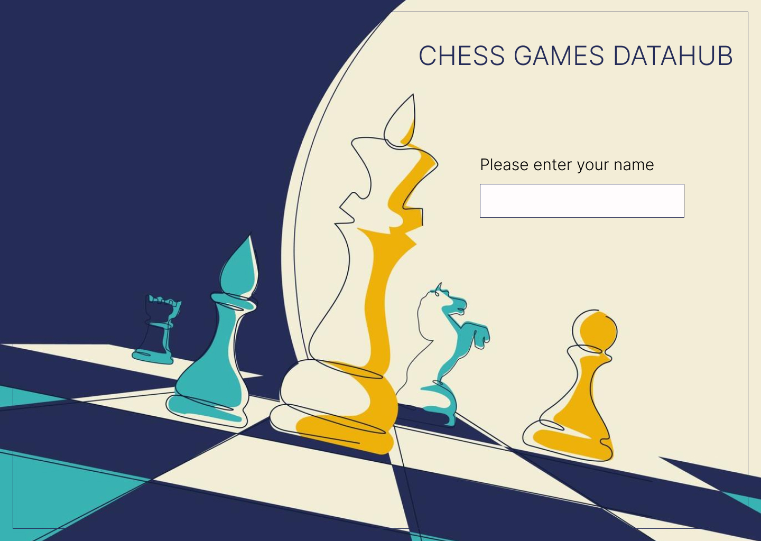

Once the user enters their name, they will be guided to the main page and can navigate through it.

This page has access to much information about chess, which is pulled from a LiChess database with over 20,000 games and 16 columns.

Through this page, we’ve tried to organize this extensive chess data to make it easy for the users to go through the basic information of each game, such as the players, ratings, opening, and the PGN(Chess notation of the game).

Also, this page contains the following info tabs:

* Game ID
* Opening Name
* Select your move
* Rated
* White Rating
* Black Rating
* Minutes
* Increments
* Turns
* Victory Status
* Winner

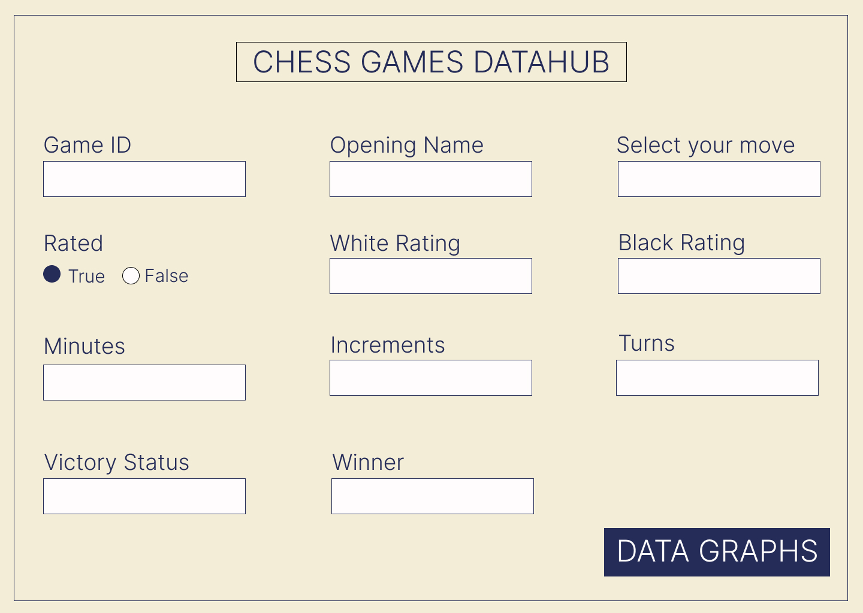

We used the following color scheme:

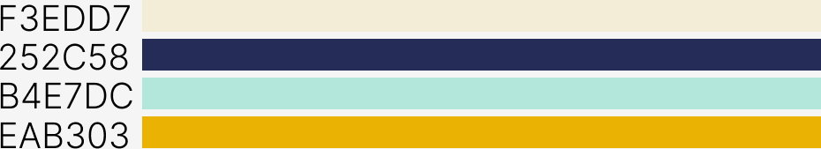

The third page is the graphs page; through this page, users can select a visualization of the data they’ve searched from the list of predetermined graph types. So we plan to use graphs to capture relationships and connections between data entities. Also, graphs

make it easier to explore those connections and draw new conclusions concerning our database.

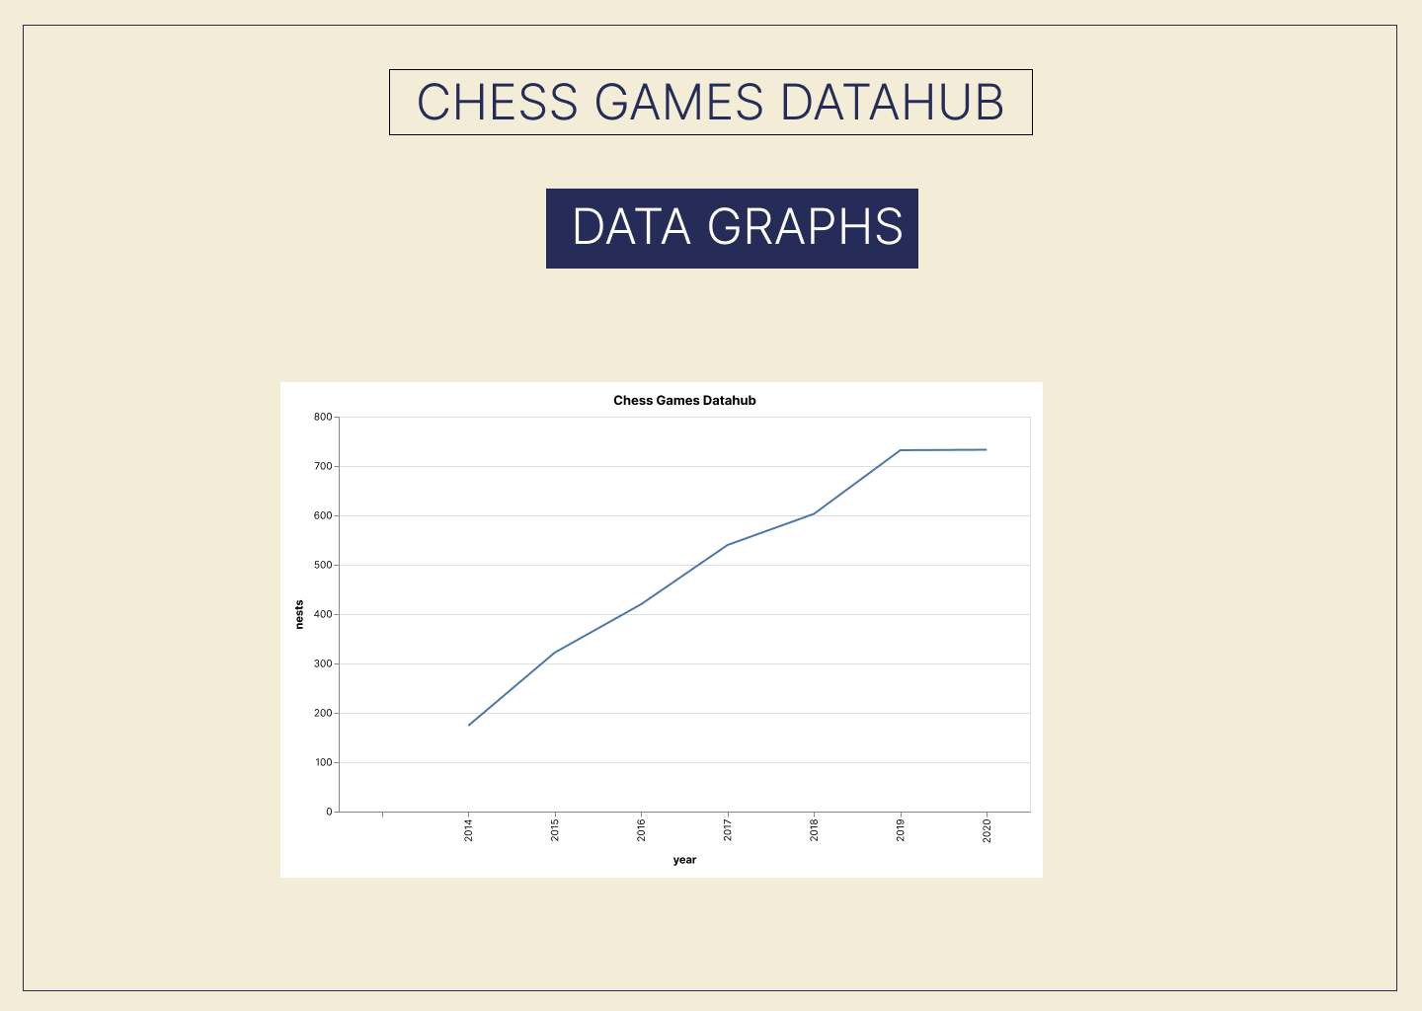

Here’s the Figma link to our web app layout:

<https://www.figma.com/file/uys2MAMuIfelInWtw3gpAC/Untitled?node-id=0%3A1>

**Section 3. Individual and Teamwork Assessment**

We have been committed to deadlines and delighted with how my team responds to tasks. I am satisfied with how my project has been scoped. The entire credit must be given to **teamwork**. Overall,

* Personal Satisfaction on Project: 9/10
* Asses Teamwork: 9/10.